Lab Exercise 4- Signed Commits in Git and GitHub
Objective:
To configure Git to sign commits with GPG, push them to GitHub, and verify commit authenticity for secure code contribution.

Prerequisites:
- Git installed on your system
- GPG (GNU Privacy Guard) installed and configured
- GitHub account with a repository (you own or have write access to)
- Basic knowledge of Git commands

Step 1 – Generate or Use an Existing GPG Key
- Check for existing keys


- If no key exists, generate a new one
  - Select RSA and RSA
  - Key size: 4096
  - Expiration: 0 (never) or a fixed date
  - Enter your GitHub-registered name and email
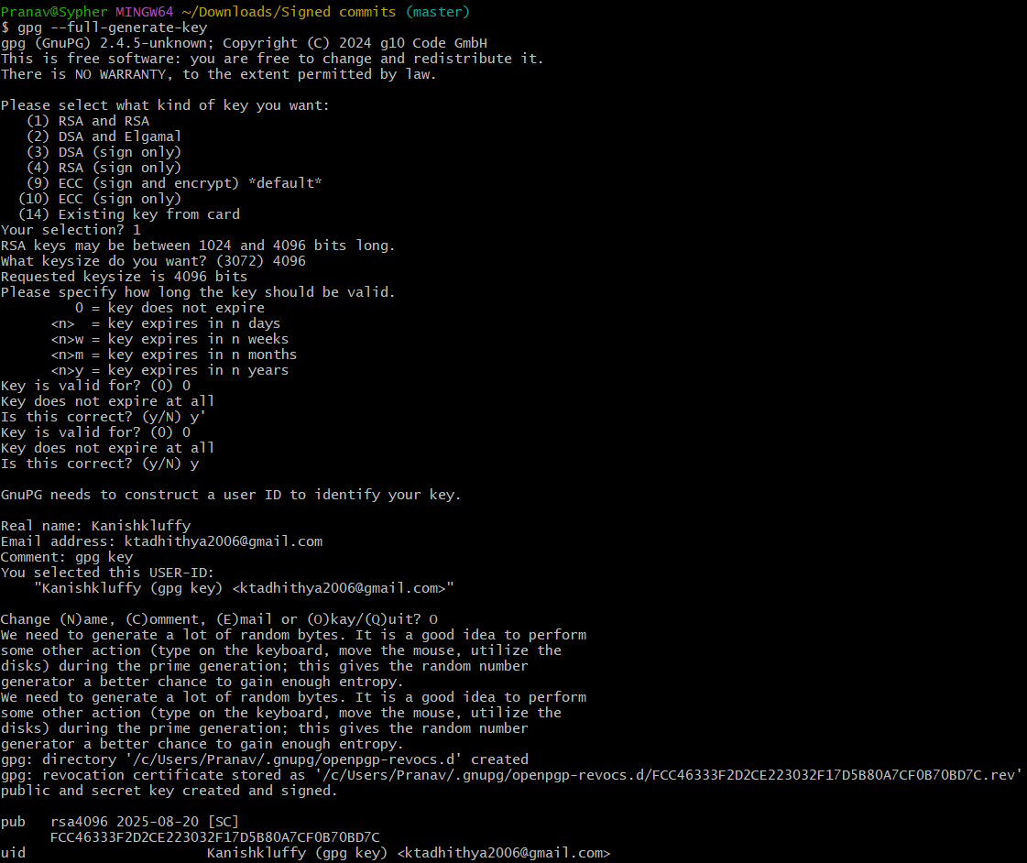

- Get your key ID
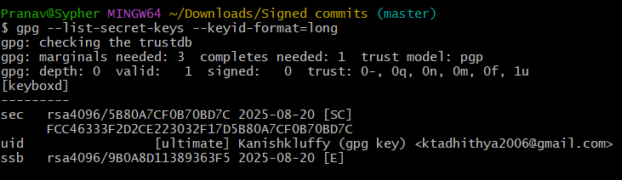

Step 2 – Add GPG Key to GitHub
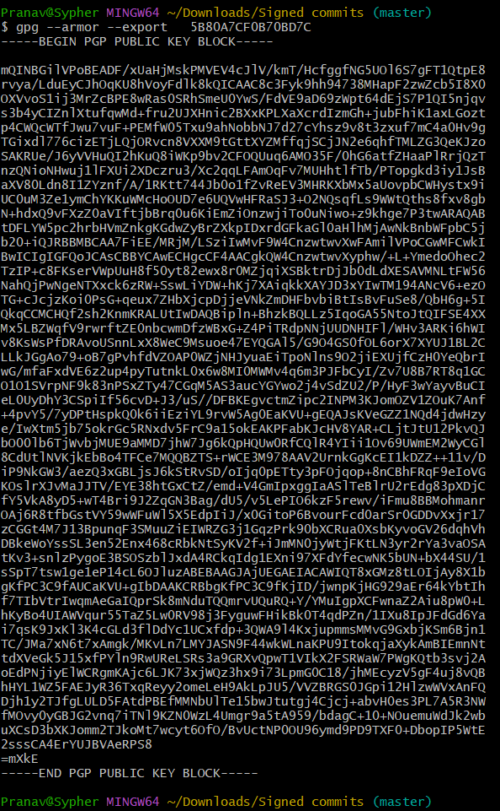
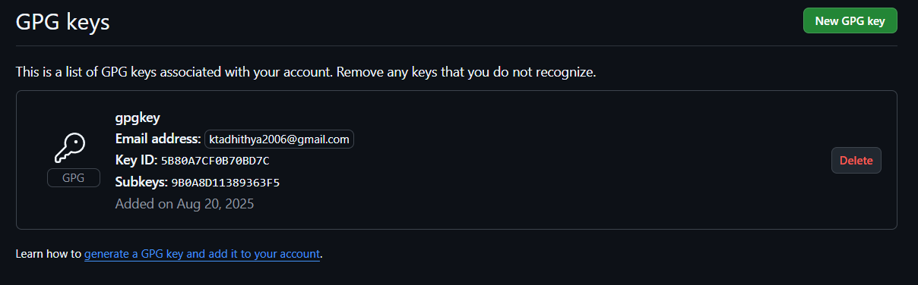

Step 3 – Configure Git for Signed Commits
- Tell Git which key to use:
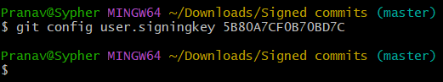

- Enable signing for all commits:
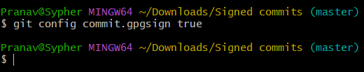

Step 4 – Make a Signed Commit
- Clone your repo (or use an existing one):
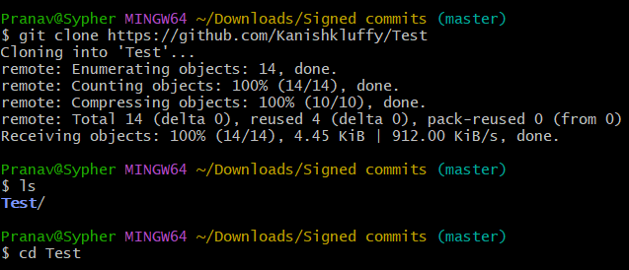

- Edit or create a file:
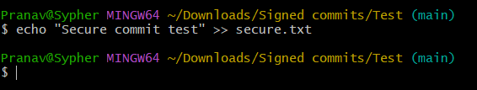
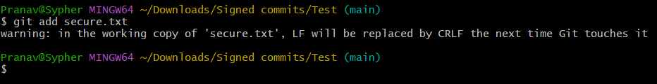

- Commit with signing:
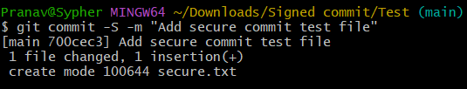

- Enter your GPG passphrase when prompted.
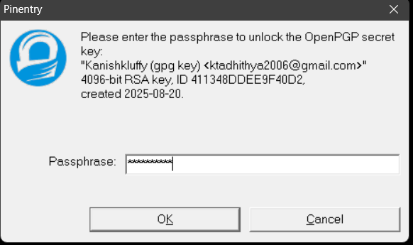

Step 5 – Push and Verify on GitHub
- Push the commit:
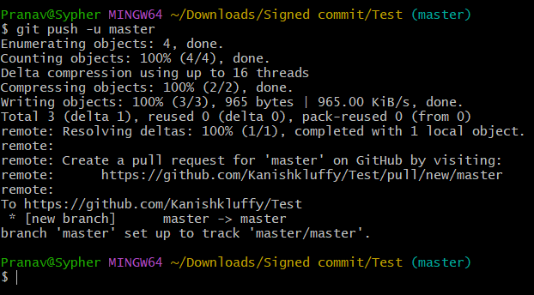

- Go to your repository on GitHub → Click the commit → You should see a green “Verified” badge.


Step 6 – Local Verification of Commit
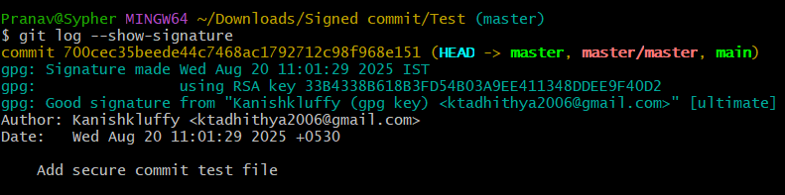

This will display the GPG verification details locally.

Use Case
Signed commits prevent identity spoofing in collaborative projects, ensuring only verified authors can make trusted changes in critical codebases.

